Github Pages and Action

[Workflow runs · VivianaMolina/IrisPredictorUI](https://github.com/VivianaMolina/IrisPredictorUI/actions)

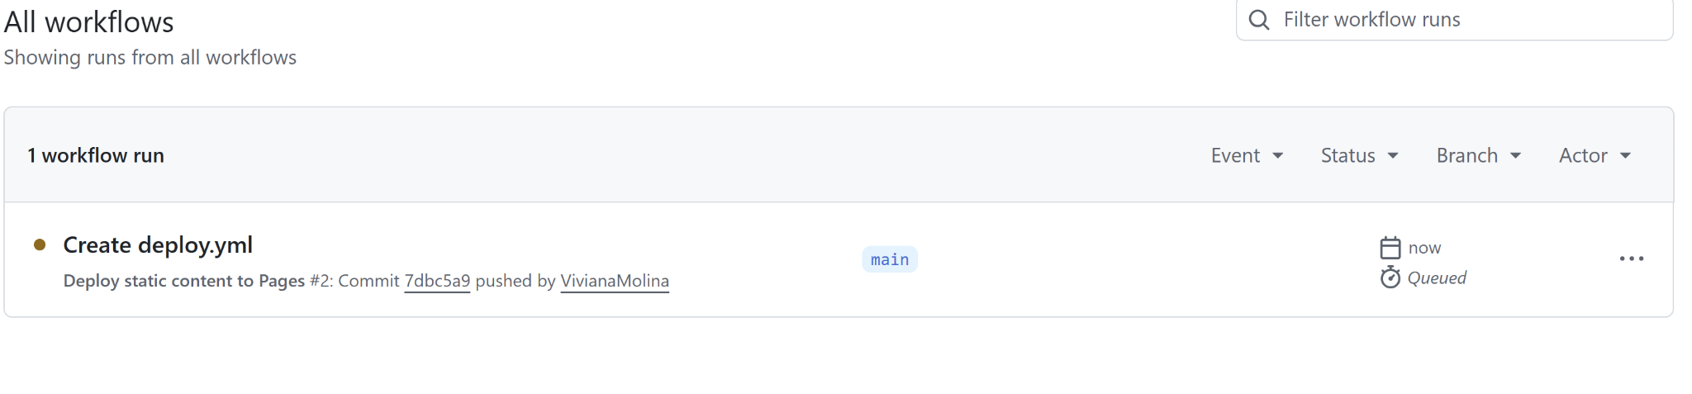

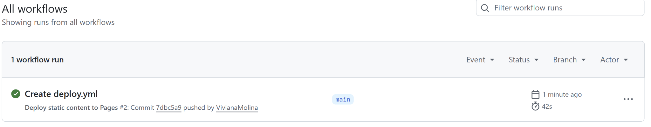

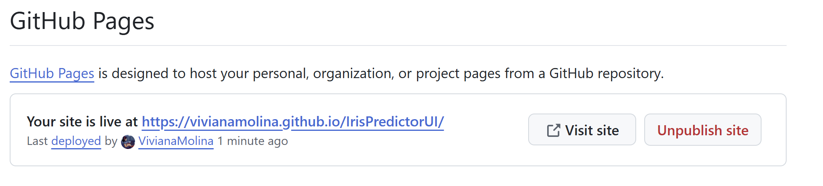

[Iris Species Predictor](https://vivianamolina.github.io/IrisPredictorUI/)

